Step : - 1 A user select multiple Category

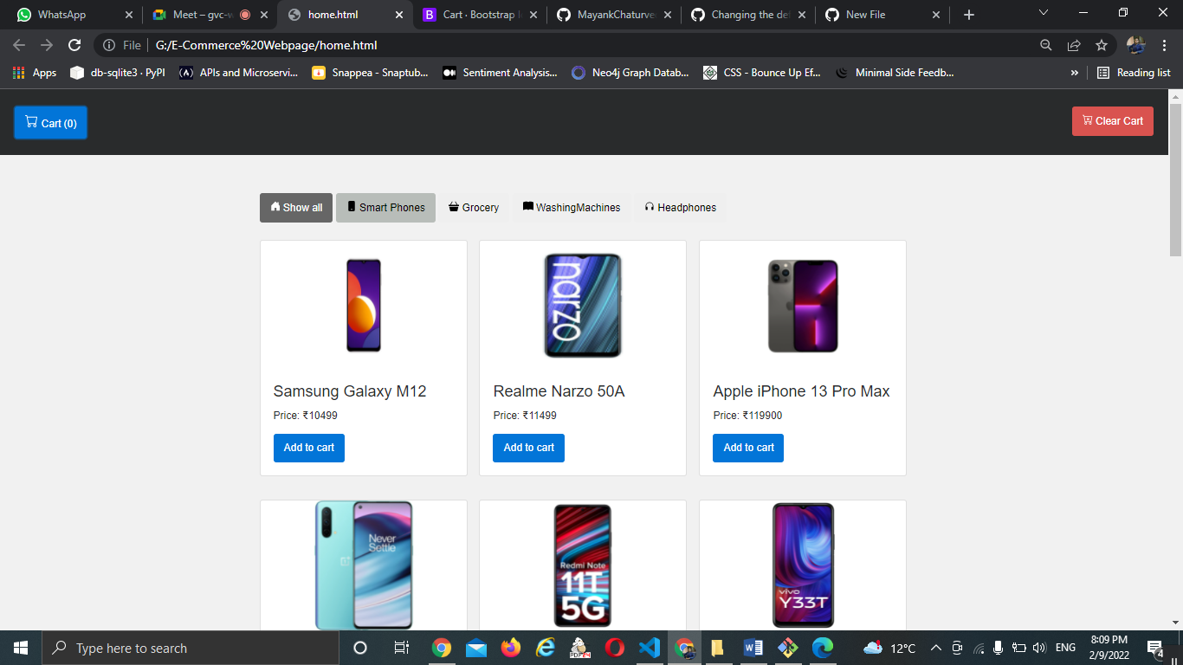

Step:- 2 A user then see the list of products of that category and add to cart them

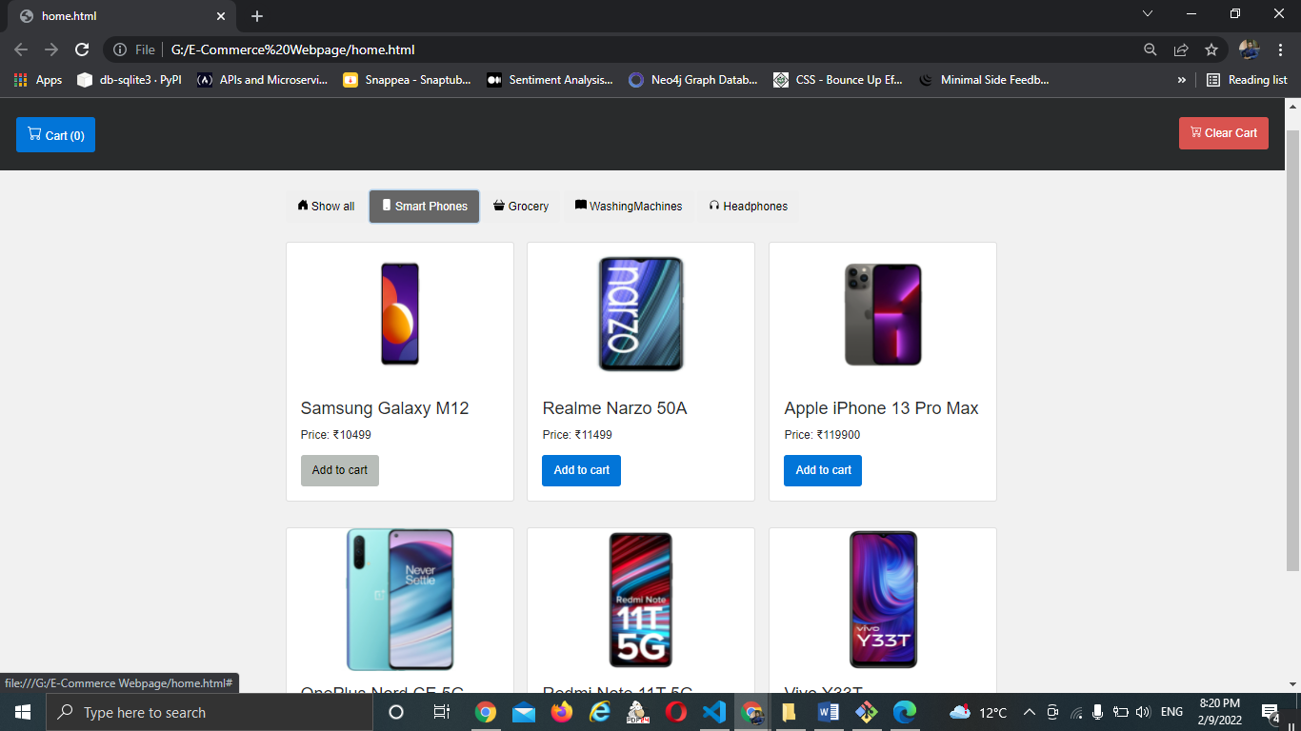

Step:- 3 A user then see the products in cart total item is shown like (“cart(1)”)

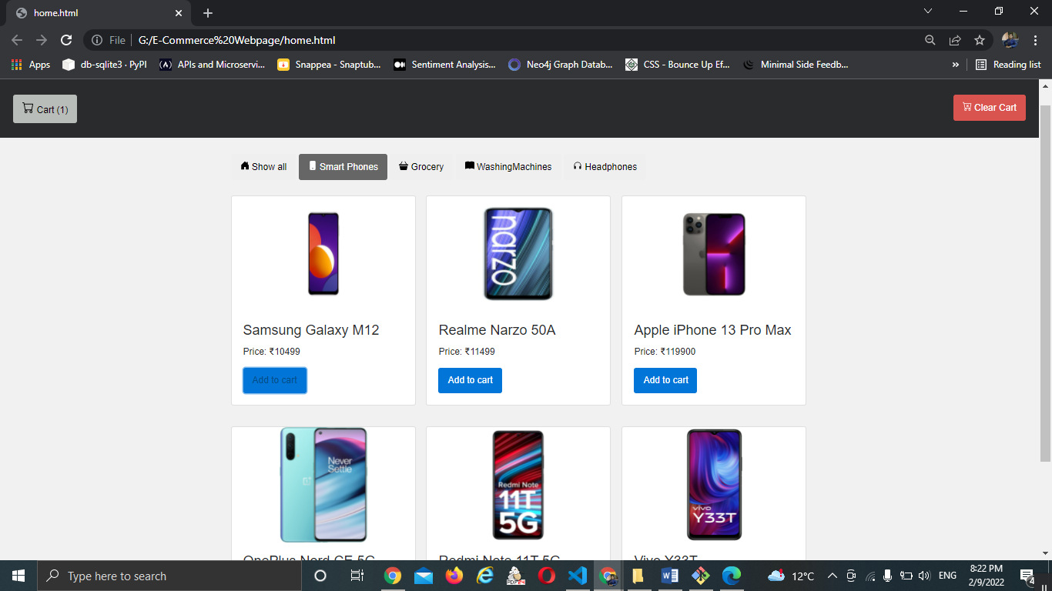

Step:- 4 A user then see the items in cart by clicking on cart button

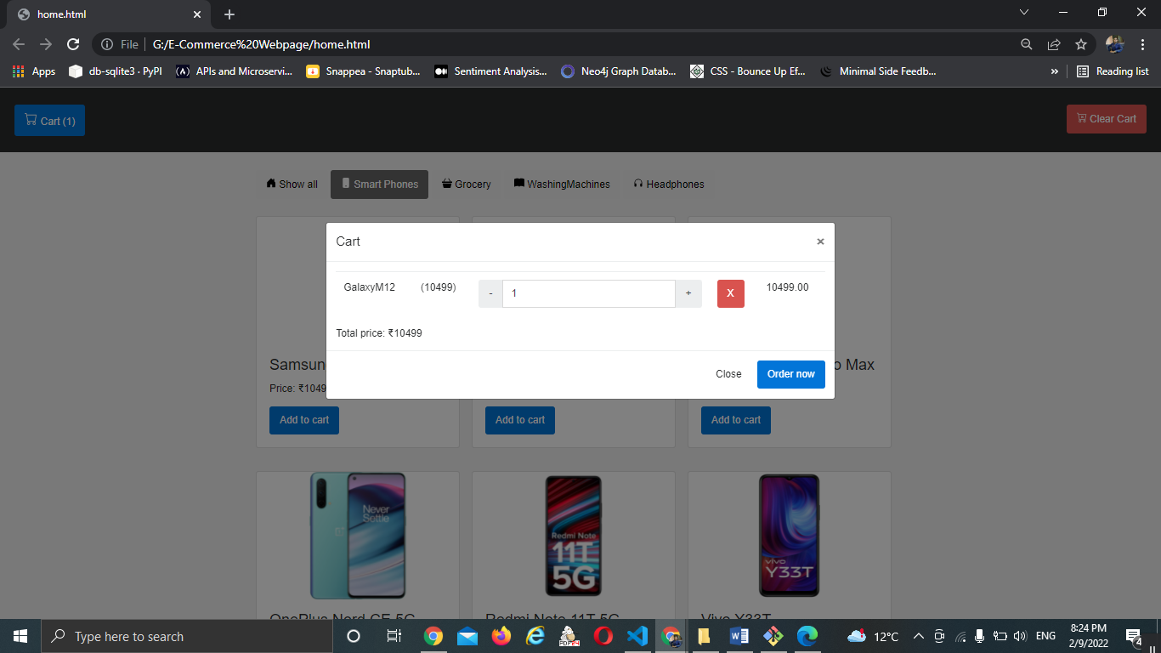

Step:- 5 A user can increase the quantity of product

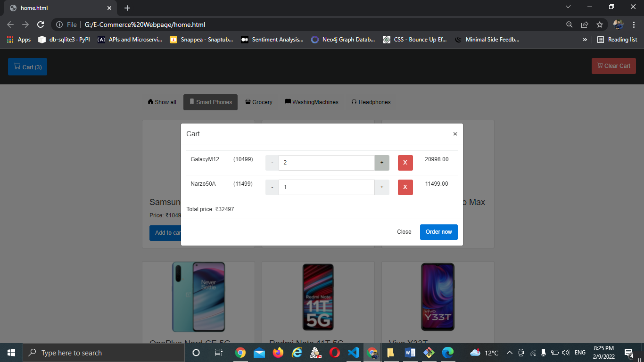

Step:- 6 A user can remove the items by clicking on cross

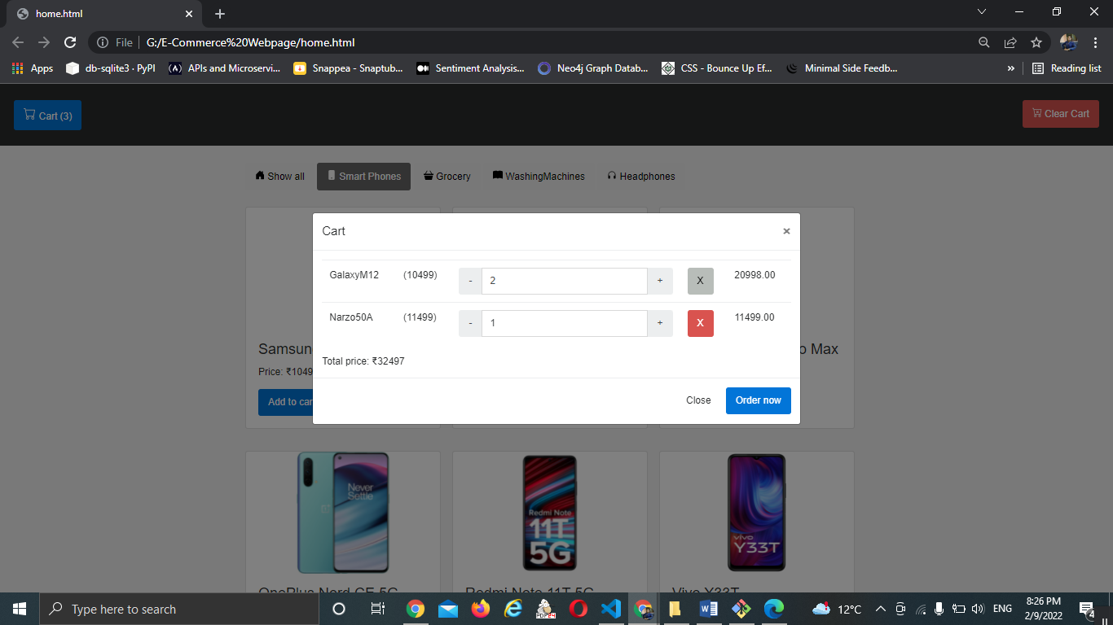

Step:- 7 A user can clear the cart by clicking on clear cart button

